Specification
  - Extrusion: ROUND 36

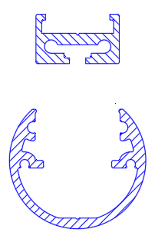

- The extrusion shall be made of aluminum alloy EN AW 6061.
- The extrusion shall be available in following surface finishes:
  - Blank
  - Anodized natural (thickness 15µm)
  - Anodized black (thickness 15µm)
  - Coated with polyester powder-coating in all standard RAL-colors
- The extrusion shall have following dimensions: diameter 36mm.
- The extrusion shall fit a LED carrying profile with following dimensions: 22mm x13mm.
- This LED carrying profile shall fit a PCB of maximum 17mm.
- The extrusion shall be available in lengths up to 6m.
- The extrusion itself shall weigh max. 2,156 kg/m
- The extrusion shall be compatible with mounting clips. These mounting clips shall serve to set the angle of the profile.
- The extrusion shall have a compatible fully closed endcap.
- The extrusion shall have compatible endcap with hole for cable.
- The extrusion shall have a compatible PMMA cover.

